# *Welcome Ambassador!*

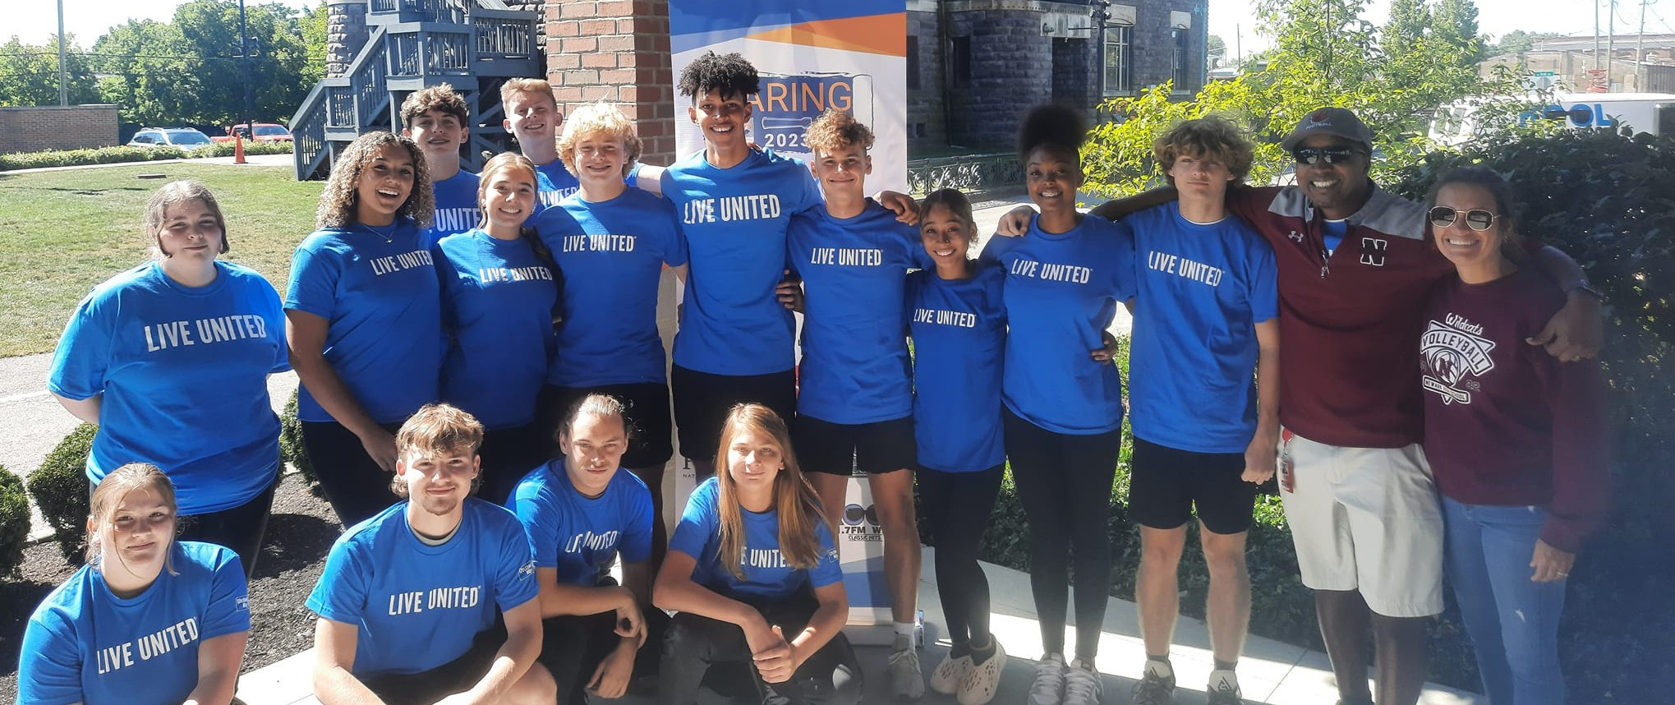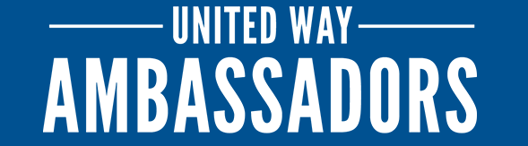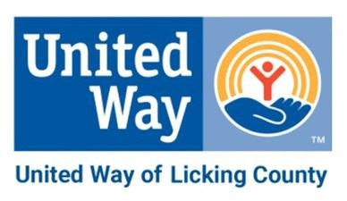

On behalf of the UWLC staff, board, and committee volunteers, thank you for volunteering your time and resources for the future of Licking County. Your efforts are a powerful investment in our community.

Every hour you volunteer and every dollar you donate helps build a stronger, more vibrant Licking County.

At UWLC, we strive to be the ancestors the next generation needs. As an Ambassador, you are shaping the future by distributing valuable funds and volunteers to our non-profit sector.

*AMBASSADOR WORKBOOK*

Why United Way?

The Role of An Ambassador

Campaign Options Engagement Ideas

*2023*

*IMPACT*

## *44*

PROGRAMS FUNDED

## *2,500+*

VOLUNTEER HOURS

## *117,596*

SERVICES PROVIDED

## *$1M*

DISTRIBUTED TO

PARTNERS & PROGRAMS

# *Why United Way?*

Donating to United Way transforms your contribution into lasting change by funding local initiatives that address:

**POVERTY**

**BEHAVIORAL HEALTH**

**CHILDREN, YOUTH & FAMILIES**

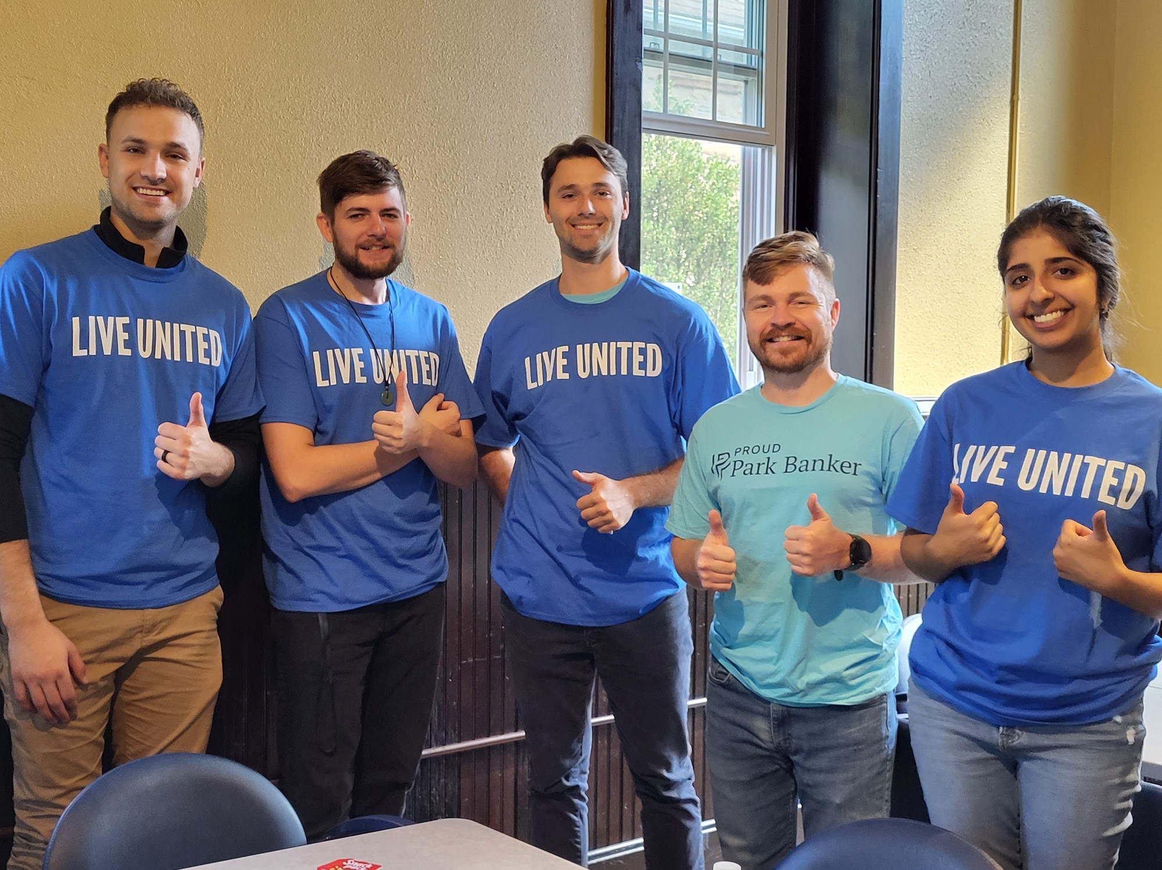Your donation supports a vast network of nonprofits, ensuring that help reaches those who need it most. United Way rigorously evaluates programs to ensure donations have the maximum impact, guaranteeing that your gift makes a real difference in the community. By donating, you join a collective effort that leverages partnerships and resources to tackle complex social issues effectively.

# *The Role of an* Ambassador

United Way Ambassadors serve as leaders within their respective organizations who plan, organize, and coordinate everything United Way. We count on you to do more than simply manage the campaign process. You represent the mission of United Way in your workplace. The job of an Ambassador may look different, but is ultimately rooted in the same goal:

**Improving lives by unity the community.**

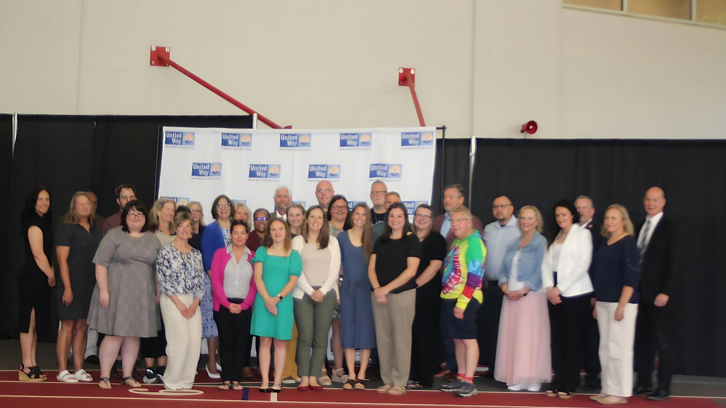

In your role as Ambassador, you will

1. **Spread the word** about United Way. People are looking for ways to give back, but don’t know how
2. **Connect** with others and **Be a Connector** in your network. We all must work together to create lasting change.
3. **Encourage a culture of philanthropy** in your workplace that enables everyone to...

**...reach their full potential.**

***phi·lan· thro·py***

[fəˈlanTHrəpē] NOUN

1. the desire to promote the welfare of others
2. goodwill to fellow

members of the human

race

CAMPAIGN CHECKLIST:

* Attend a UWLC Ambassador

Workshop

* Complete your Organization

Information Form

* Meet with a

UWLC rep to talk about your

campaign and

establish a goal

* Get your

campaign team and CEO on

board

* Plan your kickoff and engagement plans during campaign

# *Your UWLC Campaign*

Consider a few things when you are planning your United Way campaign...

### Industry Trends

When planning your United Way campaign, it's crucial to pay attention to industry trends. Avoid busy seasons and holidays. What big events bring the workplace together that you can use to jumpstart your campaign?

### Ease of Giving

We are always looking to make giving to United Way easy for all of our donors. We are doing more than just a paper pledge form!

 Evergreen Giving

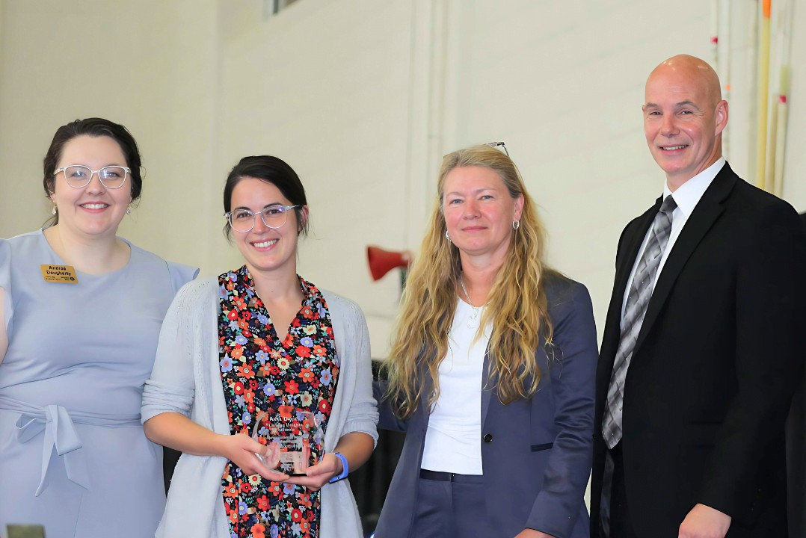 Virtual Campaign (Text-to-Give)  Special Events & Fundraisers

# *Campaign Options &* Engagement Ideas



### Evergreen Campaign

You may be a good candidate for an evergreen campaign if your workplace looks like this...

 less than 10 employees  continuous giving

 consistently volunteer and engage at United Way

### Virtual Campaign

As more and more workplaces are opting for remote or hybrid work, we’ve adapted to meet the need for a virtual giving option.

### Special Events & Fundraisers

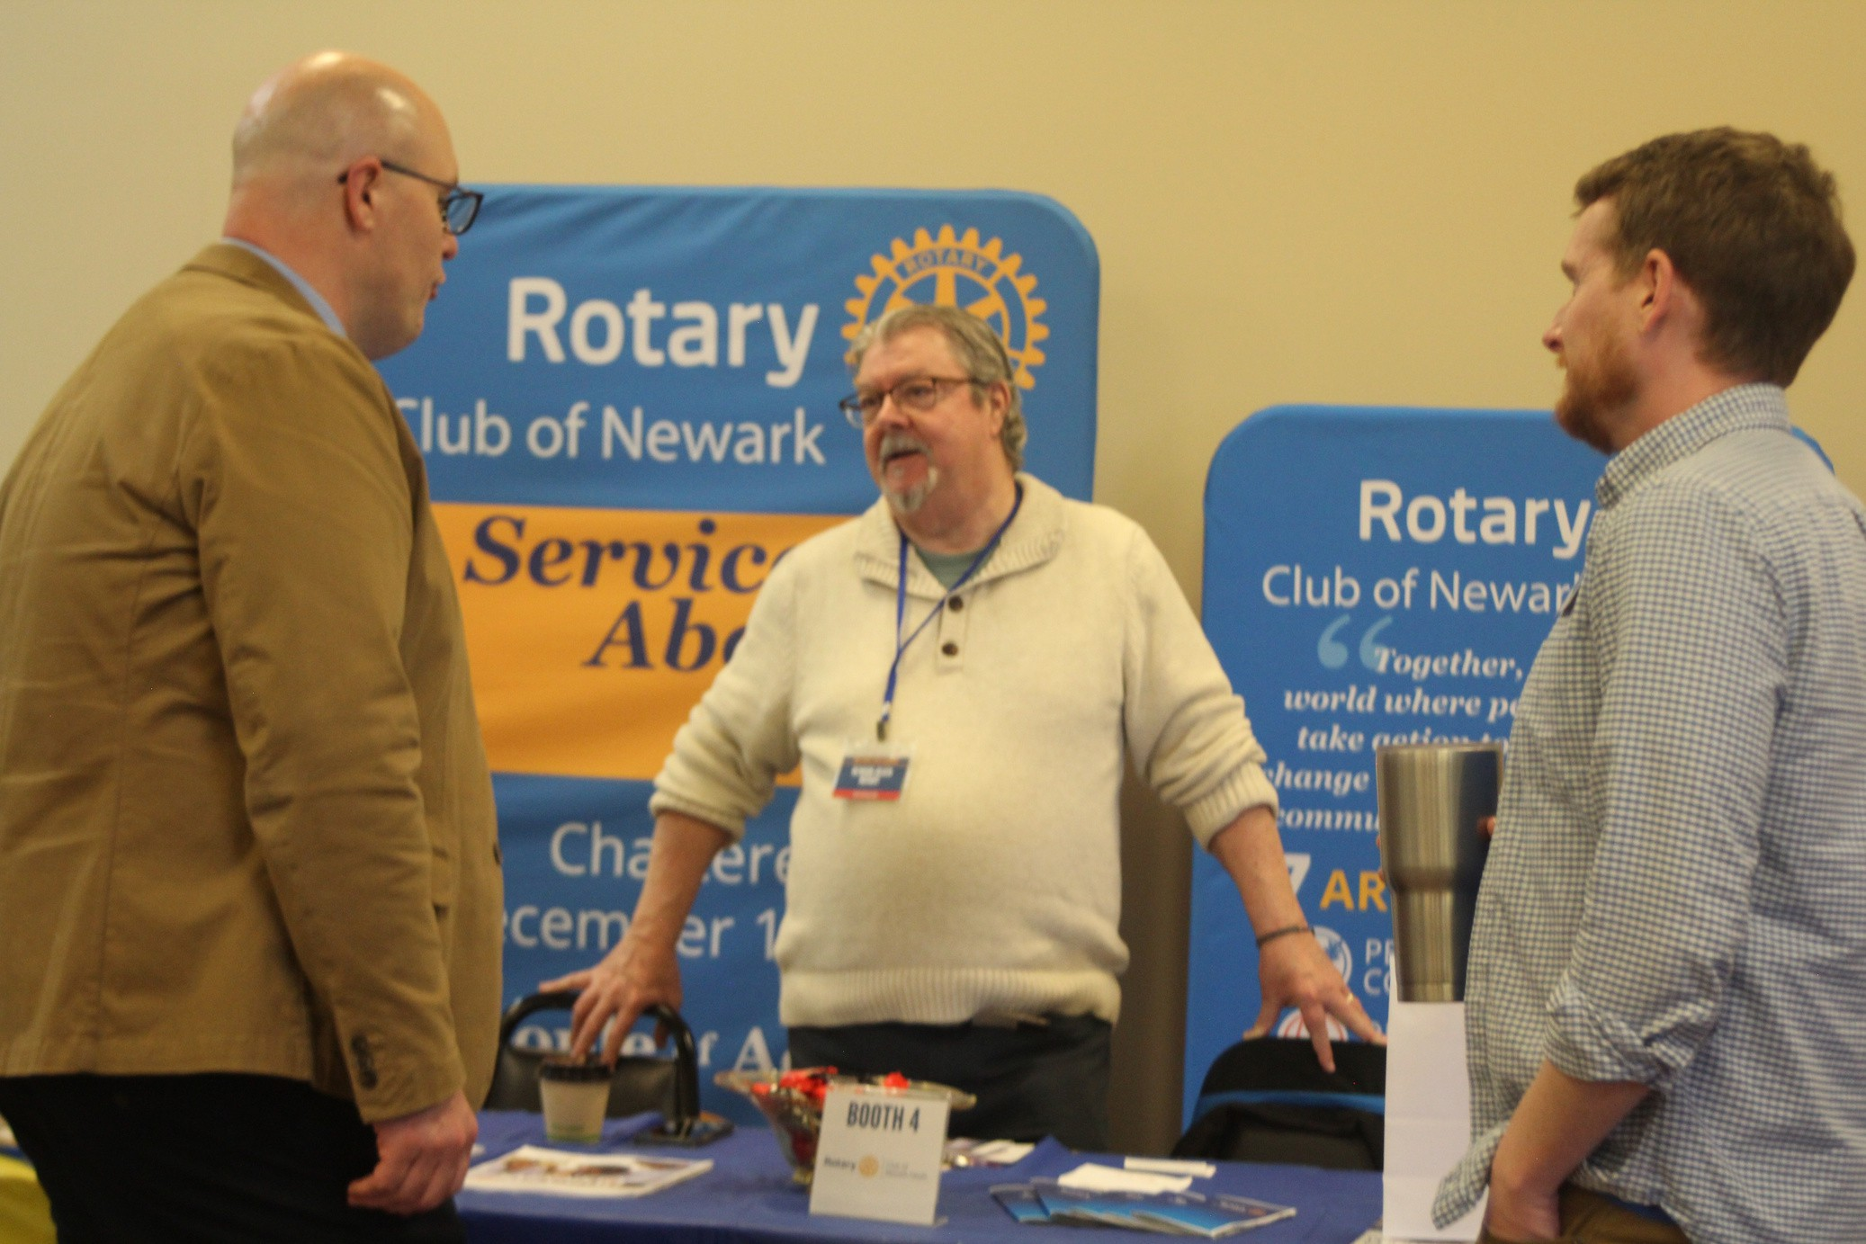If you are a retail location, restaurant, or just like having special events, you can host an event to boost your campaign beyond pledged giving.

Engagement Ideas

Use this space to write in some

ideas from your breakout groups.

_________________

_________________

_________________

_________________

_________________

_________________

_________________

_________________

_________________

_________________

_________________

_________________

_________________

_________________

_________________

_________________

_________________

UWLC Hygiene Hub Initiative



Starting Fall 2024, UWLC will have

Hygiene Hubs in four school

districts.

Newark City Schools

Heath City Schools

Licking Valley Schools

North Fork Schools

Our goal is to have hubs in every

school district across Licking County so all students have

access to these essentials. A

hygiene drive can be a great

addition to your campaign!

# *Volunteering*

### 85% of donors started as volunteers.

Research shows that volunteering is one of the most impactful ways to increase giving for a non- profit entity. Not only that, but it makes you feel good to be in the community!

Consider a volunteer opportunity to kickstart your campaign or to celebrate a successful campaign. We have a wide variety of options and can even bring the materials to you. On the flip side, volunteering is a great way to get out of the office and see firsthand where your dollars are going.

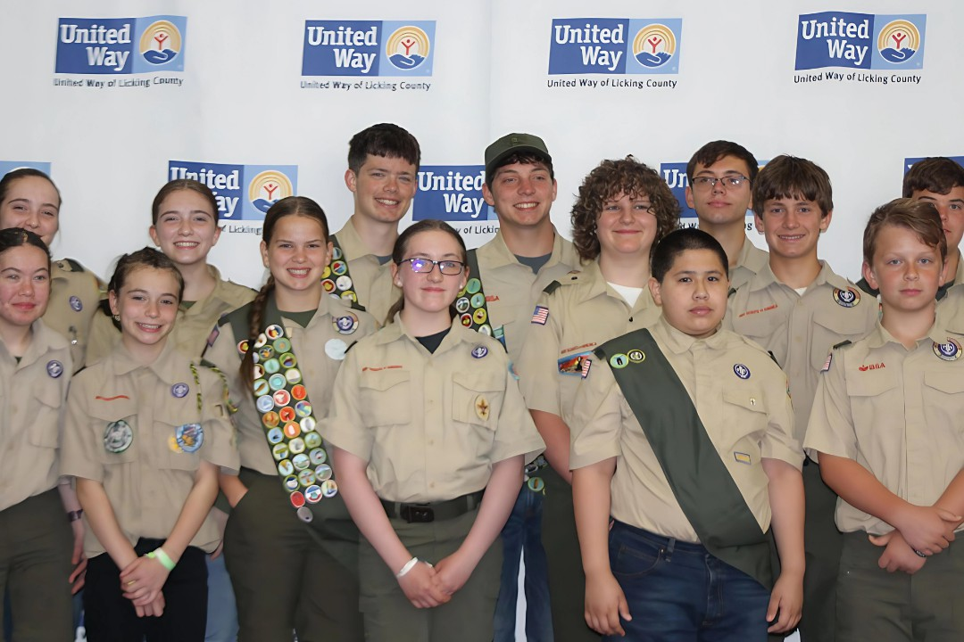

# *Week of Caring*

Join us as we celebrate our 30th Annual Week of Caring. Our kickoff celebration will be September 13th, with a full week of volunteer projects to follow!